**Phenotyping Using Polysomnography *Beta***

***User Information***

The user interface is designed to perform two tasks:

1. Convert signal and event data from clinical sleep recordings into a Matlab-friendly format (.mat) for analysis.
2. Analyze the ventilatory control contribution to sleep apnea using a model fitting approach (Terrill P et al., European Respiratory Journal 2014).

# © 2014 Scott Sands and Philip Terrill

# Licensing information

This Software will be released under the GNU Public License V3, and full license terms will be provided upon public release of the software.

# The beginning

The user interface can be opened in one of two ways:

1. **If you have a Matlab license:**

Ensure the folder containing PUPbeta is the “current folder” in MATLAB (note folder path near the top of the screen).

Open PUPbeta.fig from within the Matlab programming environment. (click on PUPbeta.m, select Run [F9])

1. **If you do not have a Matlab license:**

First, install Matlab Compiler Runtime (MCR) by running MCRInstaller.exe

Open PUPbeta.exe.

A user-interface identical to Figure 1 should appear.

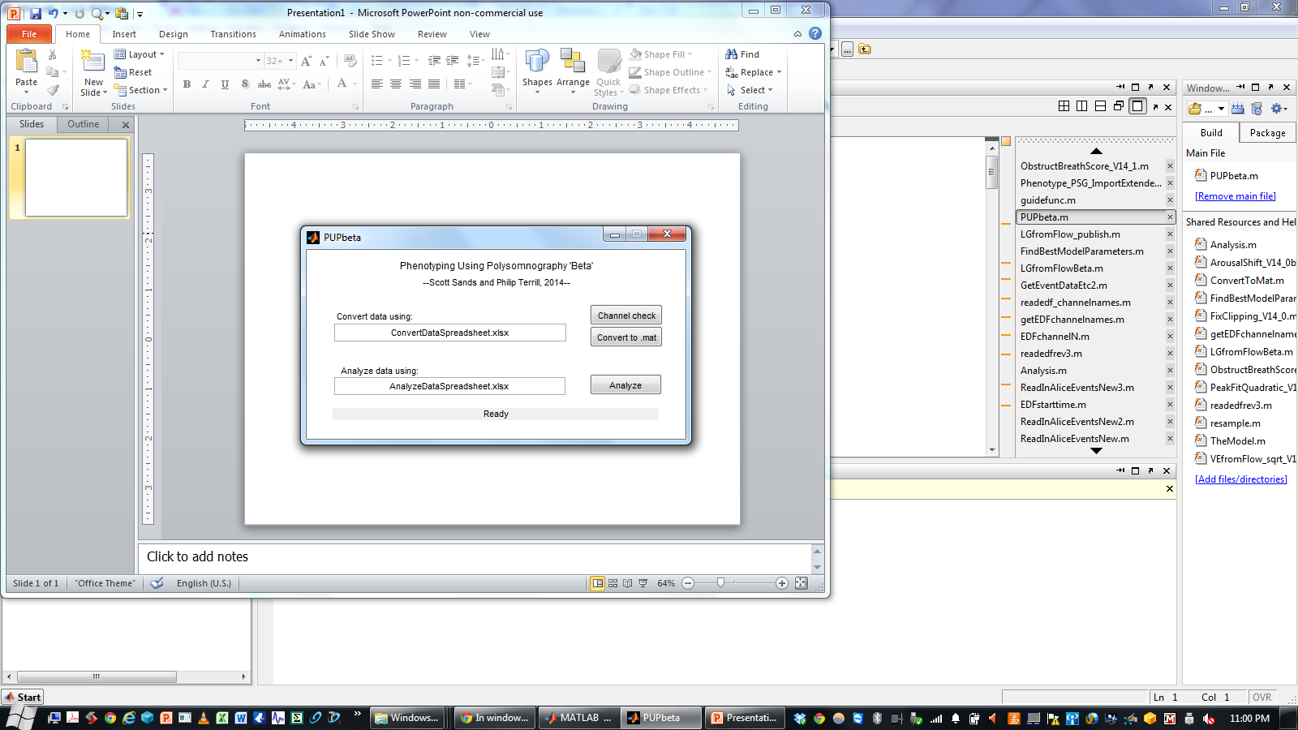

Figure 1. Phenotyping Using Polysomnography user interface.

# Exporting Data from Clinical Software

First we export the (a) signals, (b) respiratory events and arousal data, and (c) sleep state “hypnogram” data out of the clinical software package. This is done differently for just about all commercial sleep systems.

PUPbeta is currently setup to convert data from Alice Sleepware (Philips Respironics) and Profusion PSG3 (Compumedics). Work is currently underway to incorporate other common systems.

**Exporting data from Alice Sleepware v2.7.43 (Alice)**

1. Exporting signals to .edf:

File → Export → Export to EDF format

1. Exporting event data to .csv:

View events [F2], Right-click in blank space to the right of the list → Save/Export

1. Exporting sleep state data to .csv:

View signals [F4], View Channel List [Ctrl+I], unselect all except “Stage”.

Scroll to start of file, Right-click → Start Highlight Period

Scroll to end of file, Right-click → End Highlight Period

File → Range Extract [Ctrl+X]

File is saved as STAGE.csv and is in ...documents\Alice Sleepware Out\data\

Rename data as appropriate (e.g. 1234.edf, 1234e.csv and 1234h.csv) and move to your storage directory for conversion.

**Exporting data from Alice Sleepware G3 (AliceSleepwareG3)**

No exporting is necessary. Confirm that a single .edf is available and .rml file is present in the study directory. If multiple .edfs are present you will need to merge these into a single file before running PUP.

**Exporting data from Profusion PSG3 v3.4 using .csv (Profusion)**

1. Exporting signals to .edf:

Tools → Export as EDF...

1. Exporting event data to .csv:

View Scored Events [F12], Click icon “Export Scored Events”

1. Exporting sleep state data to .csv:

Tools → Export Hypnogram as ASCII...

**Exporting data from Profusion PSG3 v3.4 using .XML (ProfusionXML)**

1. Exporting signals to .edf:

Tools → Export as EDF...

The .xml file accompanying the EDF contains the scoring/staging annotations data

**Exporting data from Spike v7.11 (Spike)**

1. Channels denoting arousals/events must be named “Evts” or “New_Evts”. If there are two channels of arousals and respiratory events, rename one of these “Evts2”.

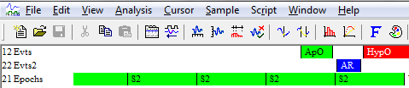

Figure 2. Change event channel names to Evts and Evts2.

1. Possible channel names:
   * 'Pnasal','PNasal','Pmask','PMask','Vflow'
   * 'SaO2','SpO2','Sat','Sao2','Spo2','O2sat','o2sat'
   * 'Thorax','RC','Chest','CHEST','Belt2'
   * 'Abdomen','ABD','Abdom','ABDM','Belt1'
   * 'Position','Pos','pos','position'
   * 'EEG','EEG_C3_A2','C3_A2'
2. Exporting to MATLAB:

Ensure the channels in (b) are visible.

File → Export As...

Save as type Matlab data (.mat)

Channel list: “Visible Channels”

Time range: 0 to Maxtime()

Click: “Add”

Click: “Export”

Unclick “Use source name in Matlab variable names”

Click “Use source channel name in variable names”

Click “OK”

# Select Data to Convert

Use the provided spreadsheet entitled “ConvertDataSpreadsheet.xlsx” to tell PUPbeta which files to convert to .mat

Cells E3:K4 will looks like this:

**Filename Information**

|  |  |  |  |  |  |  |
| --- | --- | --- | --- | --- | --- | --- |
| Signals | Events | Sleep | Signals Dir | Events Dir | Sleep Dir | System |
| 1234.edf | 1234e.csv | 1234h.csv | X | X | X | Alice |

“X” is your storage directory for the signals, event and sleep files (e.g. 1234.edf, 1234e.csv and 1234h.csv). For example, if these files are currently located in C:\StorageDirectory, you should replace “X” with “C:\StorageDirectory”.

The example system as shown is “Alice”. Other systems that have been tested include:

* “Profusion” or “ProfusionXML”
* “Spike”

Enter the relevant information into cells F2:F7, save and close the spreadsheet.

# 

# PUP step 1: Channel check (EDF-related methods only)

Return to PUP and press the “Channel check” button

The program will open the specified .edf (1234.edf in the example) and write the channel names into cell T4 and rightwards of the “ConvertDataSpreadsheet.xlsx” spreadsheet.

Re-open ConvertDataSpreadsheet.xlsx

Find the desired channels, and enter their number in shaded cells L4:R4, e.g.:

**EDF channel number**

|  |  |  |  |  |  |  |
| --- | --- | --- | --- | --- | --- | --- |
| Pnasal | Chest RIP | Abd. RIP | SpO2 | EEG | Position | CPAP |
| 8 | 10 | 11 | 7 | 5 | 15 |  |

In this example the channel named “NAF” is the known Pnasal channel and was 8th in the list. Thus we enter 8 in cell L4. If there is no CPAP channel you can leave it blank.

After entering the relevant information into cells L4:R4, save the spreadsheet.

# PUP step 2: Convert to .mat

*This step is also needed for the .mat exported from Spike.*

Return to PUP and press the “Convert to .mat” button

The PUP converter combines the recorded signals, and scored events and sleep stage data into a single .mat file with the same name as the .edf (e.g. 1234.mat). This file is saved in the same directory as the PUP program and accompanying spreadsheets.

*For the experts*

*Inside this .mat file is a large data array called* *DataEventsHypnogMat, a channel list, and a columnheadings file. DataEventsHypnogMat contains columns of data, one for each signal of interest, which have been resampled at the same rate (default = 100 Hz) for rapid analysis. The first column of DataEventsHypnogMat is the time in seconds from the start of the first day of the sleep study. Obstructive apneas, central apneas, hypopneas and arousals are represented by 1s (if in such an event) or 0s (if not in the event). Sleep states are coded as follows: W=4, REM=3, N1=2, N2=1, N3=0.*

# PUP step 3: Analyze data

**Options**

In the spreadsheet called “AnalyzeDataSpreadsheet”, under the “Options” worksheet there are several options in cells B2:C17. You should not need to change these.

|  |  |
| --- | --- |
| Option | Value |
| savename | Dataset1 |
| Pnasaldownisinsp | 1 |
| LGfromFlowVersion | LGfromFlowBeta |
| sqrt_scaling | 1 |
| saveplots | 0 |
| plotfigure | 1 |
| usescoredcentralapneas | 1 |
| eventsarebreathsfullywithinmargins | 1 |
| havescoredcentralhypops | 0 |
| manualscoringtouchups | 0 |
| maxdelaybreaths | 5 |
| windowlengthmin | 7 |
| Fs | 100 |
| ignoreCPAPdata | 1 |
| exportresultstoxls | 1 |

Items shaded in grey can be altered if necessary:

* “savename” is the name of the .mat file with details of the analysis.
* “Pnasaldownisinsp” is set to 1 if a downwards deflection in nasal pressure reflects inspiration.
* “LGfromFlowVersion” is the current version name of the function used to calculate loop gain from the raw polysomnography signals (currently “LGfromFlowBeta”).
* “sqrt_scaling” is set to 1 for using nasal pressure or zero for using gold standard airflow.
* “saveplots” is set to 1 if you would like to store the analysis figures for each window. Warning: can slow performance.
* “plotfigure” is set to 1 if you would like to plot each analysis figure during runtime. Warning: can slow performance. Note: You cannot save the figure without plotting it.
* “Fs” is the sampling rate of the data, typically 100 Hz.
* “exportresultstoxls” is set to 1 when you would like to create a spreadsheet output of the analyzed data.

**Select files**

Setup the spreadsheet called “AnalyzeDataSpreadsheet” as follows. Cells B2:D3 will look like:

|  |  |  |
| --- | --- | --- |
| MAT filename | Directory | Invert flow |
| 1234.mat | X | 0 |

Fill in the shaded cells. In place of X, enter the path of the storage directory that you have stored the .mat file. You can set “Invert flow” to 1 if the Pnasal signal is upside-down for the one file.

After entering the relevant information into cells B3:D3, save the spreadsheet before returning to the PUP interface.

**Analyze data**

Return to PUP and press the “Analyze” button

The program will open the .mat file (e.g. 1234.mat), and start scrolling along in 2 min steps. For each 7 min window, it will determine if the period is entirely made up of NREM sleep and if there are any respiratory events present. If not, no analysis will be performed on that window.

For each window that is analyzed, a figure will pop up to show the raw data and analysis (Figure 3).

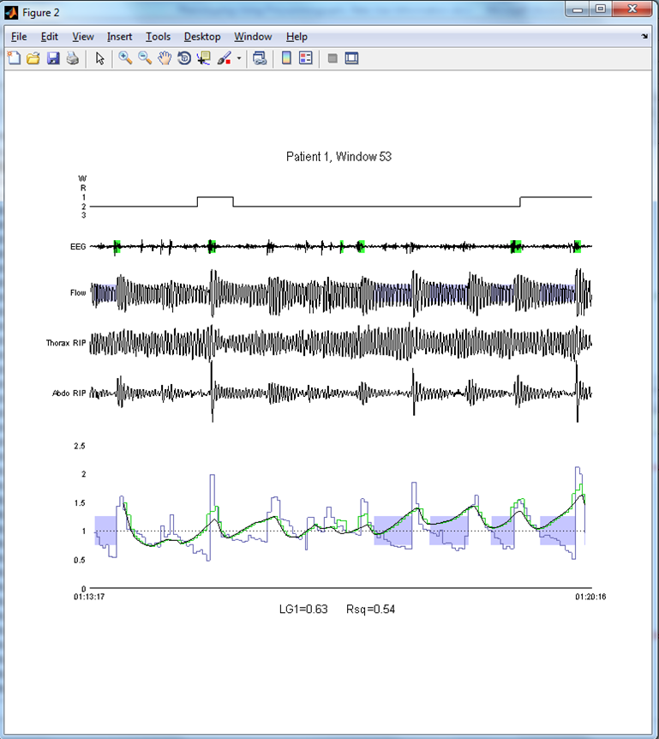

Figure 3. Example plot of analyzed data. The window number is linked to the results (see Results) enabling manual arbitration of data inclusion/exclusion if desired. From the top, the plot shows the sleep state (hypnogram), one EEG channel, flow (square-root transformed nasal pressure), thoracic and abdominal excursions, and the ventilation signals (1=mean ventilation). The surrogate ventilation trace is shown in light blue. Superimposed is the model-estimated chemical drive trace in black, and the model-estimated ventilatory drive trace (including non-chemical arousal-related effects) in green. Obstructive events are shown by blue shading over the ventilation signals. Arousals are shown as green shading over the EEG. The time-of-day of the start and end of the 7-min window are shown at the bottom-left and bottom-right of the trace. Summary data shown describes loop gain (LG1=0.63) and the goodness of fit (R2=0.54).

# Results

When the analysis is complete, a spreadsheet named [filename]_results.xlsx (e.g. 1234_results.xls) is produced containing the results of each window of analysis. The median data for the whole night is shown in row 5 (Figure 3):

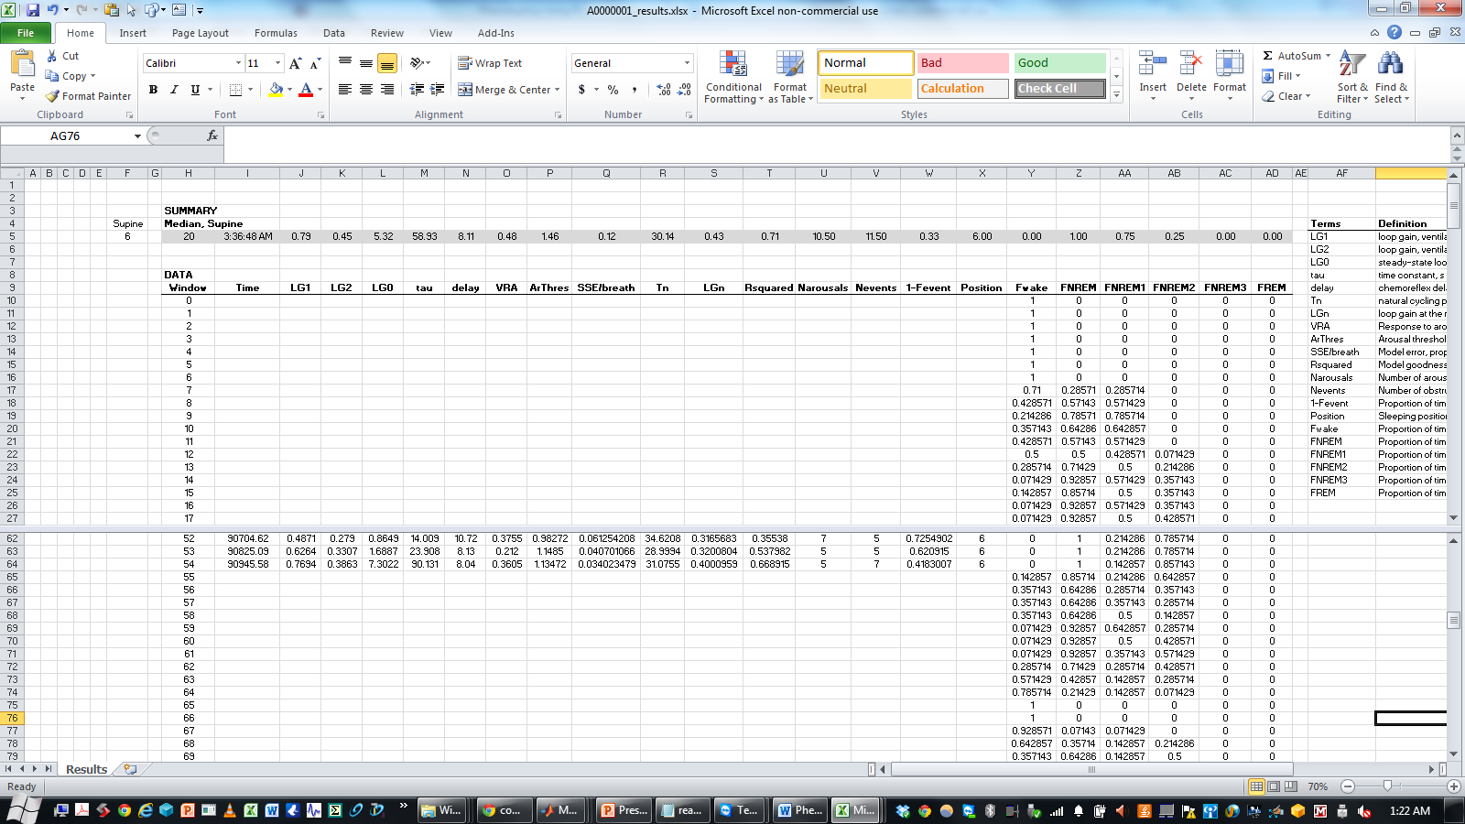

Figure 3. Results spreadsheet. In this example, supine position is designated the code “6”, which is placed in cell F5 such that only data with Position=6 is used for analysis. The meanings of the columns are described in the spreadsheet. Loop gain (LG1) is shown in column J (median = 0.79). Columns Y:AD describe the sleep state.

# Log

A textfile entitled “log.txt” is created each time the program is open and stores information regarding the previous running of the software.